Name: Krish Singh
Roll: AID25072
B.Tech Artificial Intelligence & Data Science - 2nd Semester
Object Oriented Programming – Lab Assignment 9

General Questions:
1. What problem is observed in normal class design?
Ans:

2. How does an abstract class improve correctness?
Ans:

3. How does an interface differ from an abstract class?
Ans:

4. Which approach enforces implementation more strictly?
Ans:

5. Which design is more flexible for future extension?
Ans:

Conceptual Questions:
1. When would you prefer an abstract class over an interface?
Ans:

2. When is an interface more suitable?
Ans:

3. Can a class implement multiple interfaces? Explain.
Ans:

Exercise 1:
Normal Class
Code:
class Payment{
double amount;
void pay(){
System.out.println("Processing Payment of "+amount);
}
}
public class PaymentProcessingPartA {
public static void main(String[] args) {
Payment p = new Payment();
p.pay();
}
}
Output:
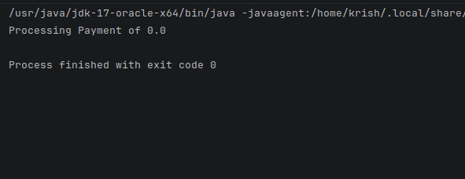

Abstract Class
Code:
abstract class PaymentB{
double amount;
PaymentB(double amt){
this.amount=amt;
}
abstract void pay();
}
class UPI extends PaymentB{
String upiId;
UPI(double amt,String upiId){
super(amt);
this.upiId=upiId;
}
void pay(){
System.out.println("UPI payment : "+amount+" using "+upiId);
}
}
public class PaymentProcessingPartB {
public static void main(String[] args) {
PaymentB p = new UPI(5000,"abstract@oksbi");
p.pay();
}
}
Output:
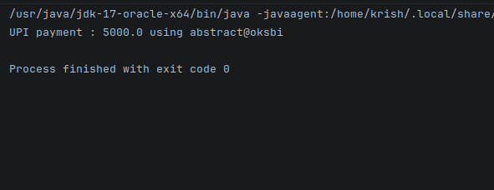
Interface Class
Code:
interface PaymentC{
void pay();
}
class UPIC implements PaymentC{
double amount;
String upiID;
UPIC(double amount,String upiID){
this.amount=amount;
this.upiID=upiID;
}
public void pay(){
System.out.println("UPI Payment : "+amount+" using "+upiID);
}
}
public class PaymentProcessingPartC{
public static void main(String[] args){
PaymentC p = new UPIC(500,"interface@oksbi");
p.pay();
}
}
Output:
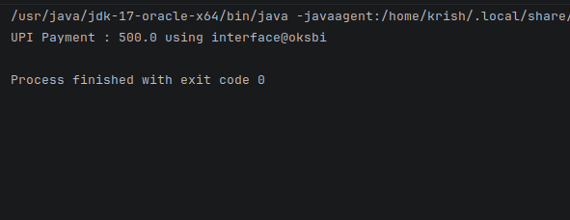

Exercise 2:
Abstract Class
Code:
abstract class Employee{
double base;
Employee(double base){
this.base=base;
}
abstract void calculateSalary();
}
class FullTime extends Employee{
FullTime(double base){
super(base);
}
void calculateSalary(){
System.out.println("Salary : "+(base+5000));
}
}
public class EmployeeSalaryAbstract{
public static void main(String[] args){
Employee e = new FullTime(35000);
e.calculateSalary();
}
}

Output:
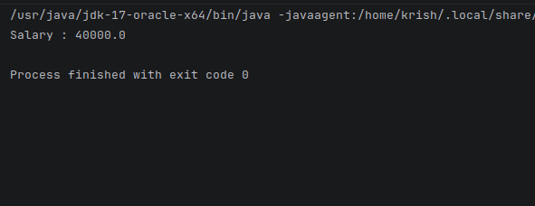

Interface Class
Code:
interface EmployeeB{
void calculateSalary();
}
class Intern implements EmployeeB{
double stipend;
Intern(double stipend){
this.stipend=stipend;
}
public void calculateSalary(){
System.out.println("Stipend : "+stipend);
}
}
public class EmployeeSalaryInterface {
public static void main(String[] args) {
EmployeeB e = new Intern(55050.5050);
e.calculateSalary();
}
}
Output:
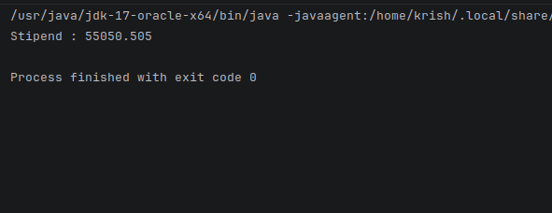

Exercise 3:
Abstract Class
Code:
abstract class Notification{
abstract void send();
}
class Email extends Notification{
void send(){
System.out.println("Sending email...");
}
}
public class NotificationSystemAbstract {
public static void main(String[] args) {
Notification n = new Email();
n.send();
}
}
Output:
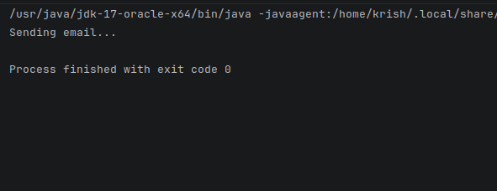

Interface Class
Code:
interface Notificationn{
void send();
}
class SMS implements Notificationn{
public void send(){
System.out.println("Sending SMS");
}
}
public class NotificationSystemInterface {
public static void main(String[] args) {
Notificationn n = new SMS();
n.send();
}
}
Output:
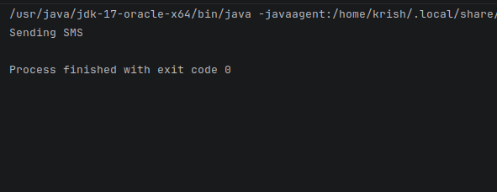

Exercise 4:
Abstract Class
Code:
abstract class Vehicle{
double distance;
Vehicle(double distance){
this.distance = distance;
}
abstract void fare();
}
class Car extends Vehicle{
Car(double distance){
super(distance);
}
void fare(){
System.out.println("Car Fare: "+distance*15);
}
}
public class VehicleFareAbstract {
public static void main(String[] args) {
Vehicle v = new Car(100);
v.fare();
}
}
Output:
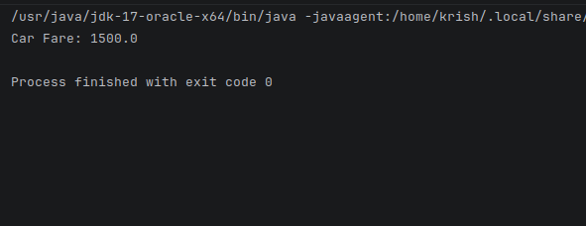

Interface Class
Code:
interface Vehiclee{
void fare();
}
class Bike implements Vehiclee{
double distance;
Bike(double distance){
this.distance = distance;
}
public void fare(){
System.out.println("Bike Fare : "+distance*8);
}
}
public class VehicleFareInterface {
public static void main(String[] args) {
Vehiclee v = new Bike(100);
v.fare();
}
}
Output:
